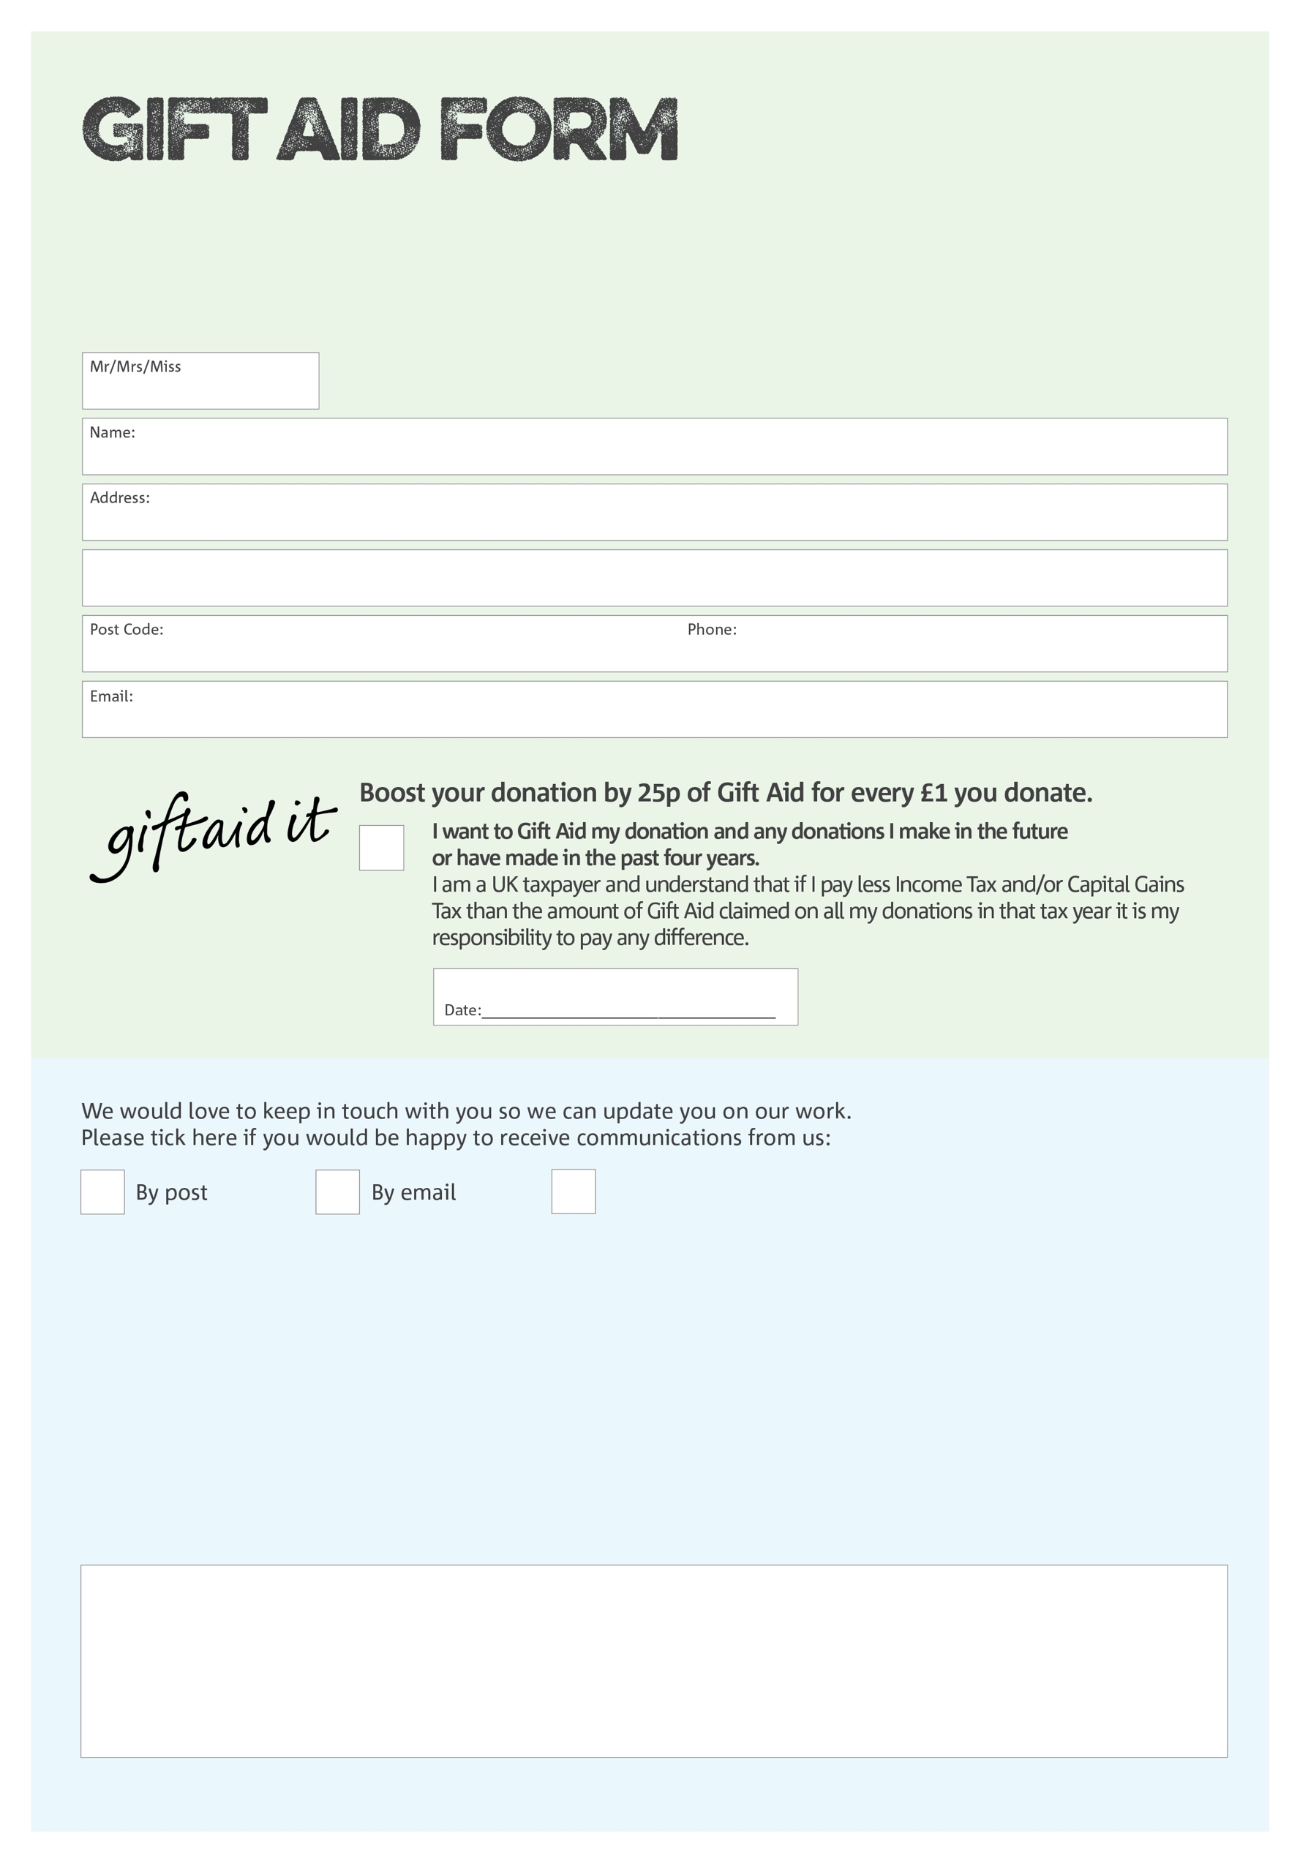

By filling in this form Good Company will receive an extra 25p for every £1 you give at no extra cost to you. Thank you!

Any personal data/special category personal data submitted herein are processed in accordance with UK data protection legislation, including UK GDPR. All feasible security is in place.

We would love to know why you have chosen to donate to Good Company (Surrey). If you would like to share your motivation let us know below:

I do not wish to receive future communications from Good Company

You can change your preferences any time by contacting us on 0208 786 8221 or emailing us on foodbank@goodcompany.org.uk

Charity Number 1197493. Registered in England and Wales.