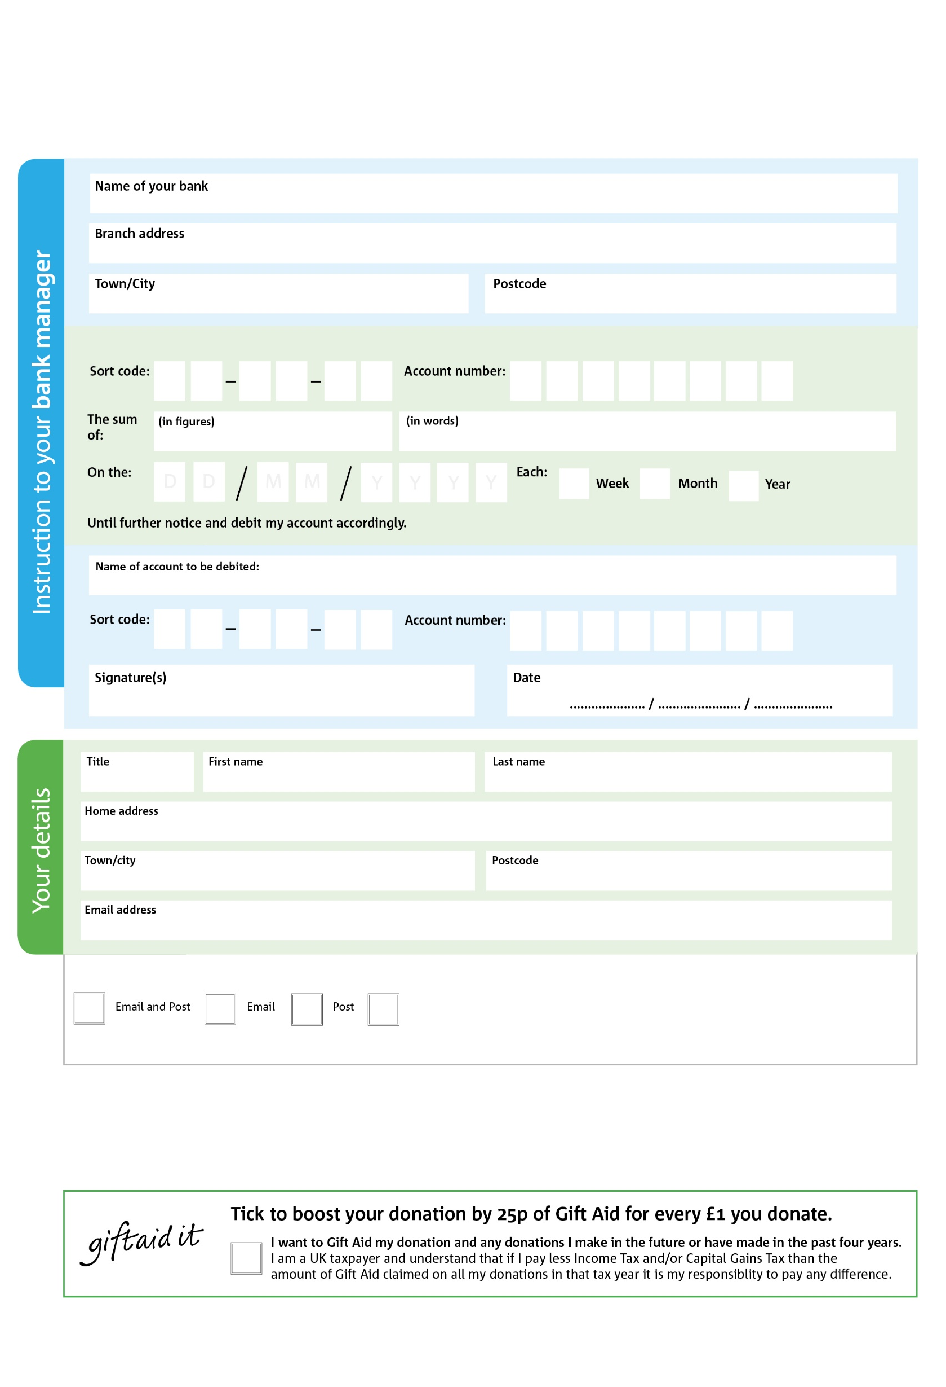

Any personal data/ special category personal data submitted herein are processed in accordance with UK data protection legislation, including UK GDPR. All feasible security is in place.

POSTAL ADDRESS: Good Company, Good Company Hub, Ruxley Lane, Ewell, KT19 0JG

Reg. Charity No: 1197493 | Reg. in England & Wales

You can change your preferences any time by contacting us on 020 8786 8221 or emailing us at foodbank@goodcompany.org.uk

I do not wish to receive future communications from Good Company

We would love to keep you up to date with information about Good Company. Please tick your preference:

**Standing Order Mandate**

**www.goodcompany.org.uk**

0

V

8

V

9

V

4

V

342

V

0

V

0

V

0

V

0

4

2

5

0

4

Please pay Good Company